Knowledge article
KB3639363 v7.0
KB2202604 v2.0
KB0010831 v8.0

KB2202604
Vendor Maintenance – Add three radial buttons (low, medium, and high) to the SK-Purchasing tab
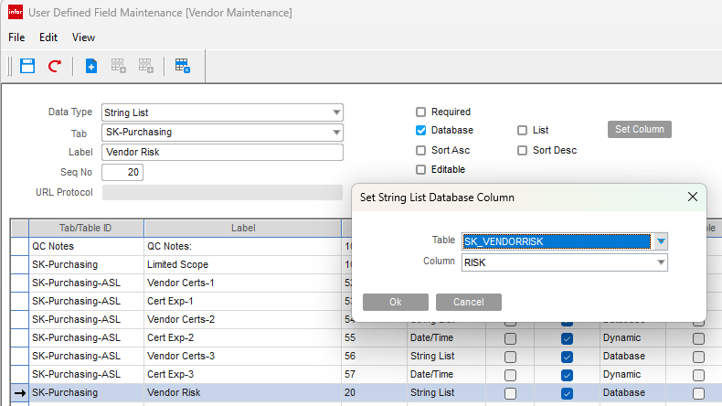
RE: Does a CUDF lookup table need to be carried forward?
The requester would like to add three values (low medium, and high) to a tab on Vendor Maintenance.
Per chapter 5 of sysadm manual.
I would like to use a lookup table, as we anticipate values will be added.
I created a table
CREATE TABLE dbo.SK_VendorRisk
(
ID int IDENTITY(1,1) NOT NULL PRIMARY KEY,
Risk nvarchar(255) NOT NULL
);

INSERT INTO dbo.SK_VendorRisk (Risk)
VALUES
('Low'),
('Medium'),
('High');
My question is, do I need to register this table name somewhere other than the CUDF maintenance screen?
Sorry for the scope of the question, the person who used to handle this is no longer with the company.

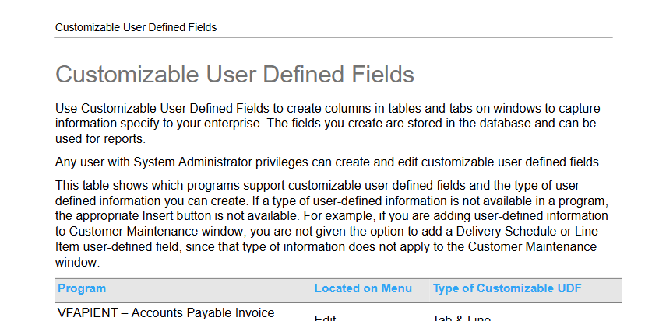
…
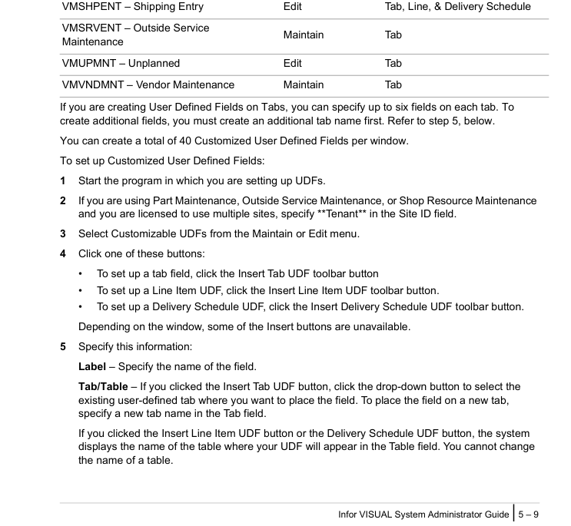
…
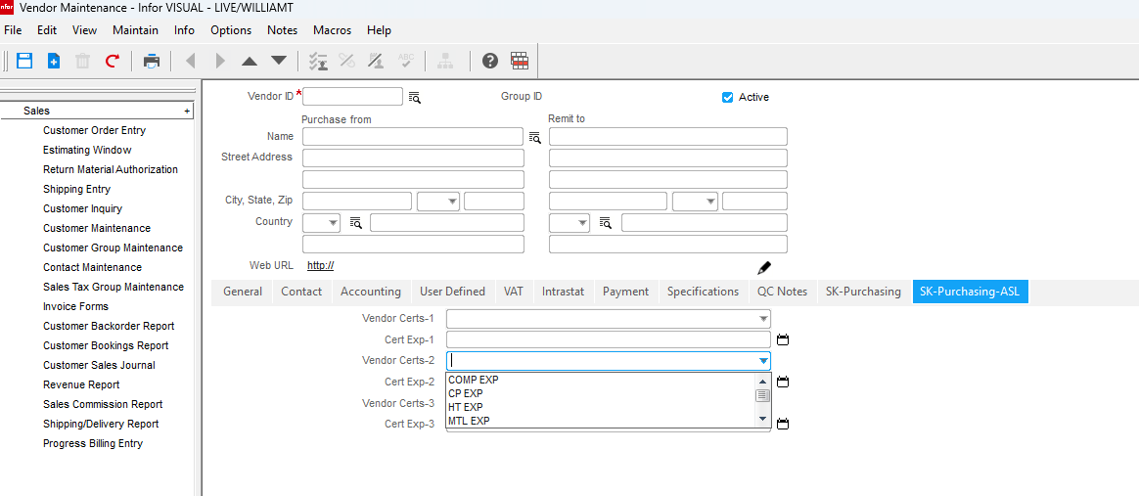
…
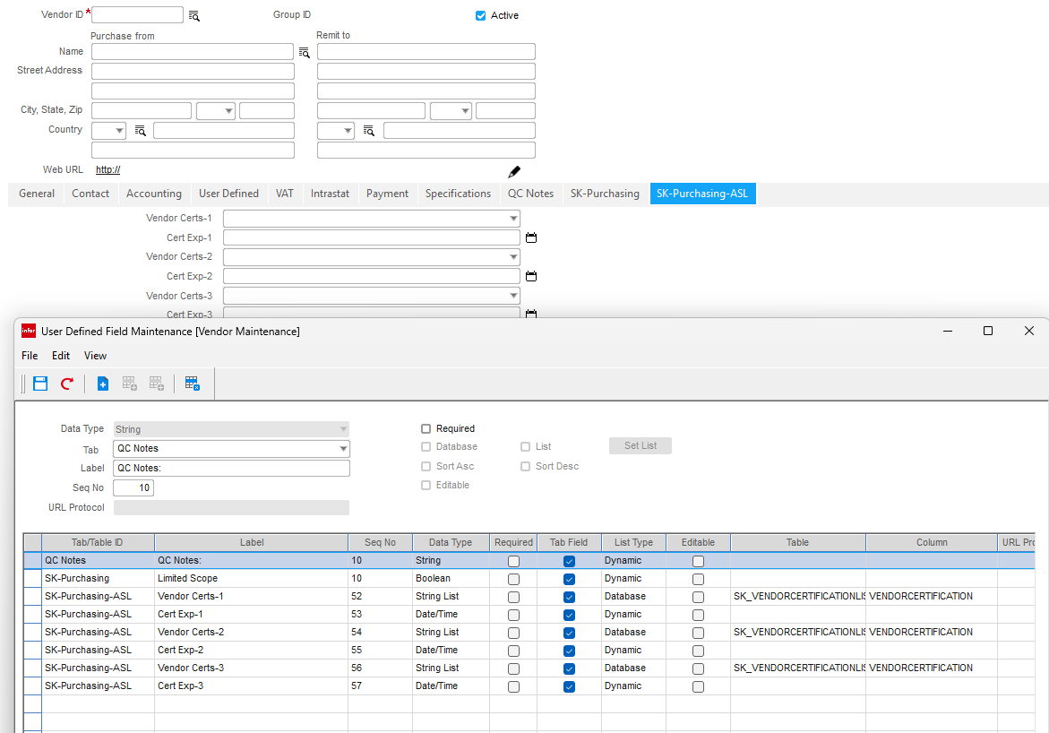
Searched for regex custom field|custom fields|user-defined field|user defined field|add custom.*field|fields to forms|customized field (**/Documentation/**), 438 results
Read , lines 3930 to 4048
Read , lines 4248 to 4318

Findings in the Infor VISUAL manuals
Yes — the manuals do cover this, and the relevant guidance is in the System Administrator and Manufacturing manuals.

1) Custom fields are handled as “Customizable User Defined Fields”
The core setup instructions are in VISUALSYSADM.md:3933-4048.
This section says:
- You can create custom fields to capture enterprise-specific information in form tabs and tables.
- Supported programs include the manufacturing window programs, including:
  - VMMFGWIN – Mfg Window – Operation Card
  - VMMFGWIN – Mfg Window – Material Card
  - VMMFGWIN – Mfg Window – Leg Card
- For tab-based fields:
  - up to 6 fields per tab
  - you can create additional tabs
  - up to 40 custom UDFs per window
- Setup flow:
  - Start the target program
  - Select Customizable UDFs from Maintain/Edit
  - Click Insert Tab UDF / Insert Line Item UDF / Insert Delivery Schedule UDF
  - Specify:
    - Label
    - Tab/Table
    - Seq No
    - Data Type
    - etc.

2) The manufacturing manual confirms how these fields appear on work-order operation forms
The operation-specific usage is described in VISUALMANUFACTURING.md:4256-4267.
It says:
- Open the User Defined tab on the operation
- Select a User Defined Field Layout ID
- Enter the values in the displayed custom fields
- These layouts can be defined from other maintenance windows and then used system-wide

Practical takeaway
This is not a code-level “add a new form control” process; it is a configuration process for Infor VISUAL User Defined Field layouts. In practice, you:
- define the field labels and data types in the system administrator setup
- assign them to a tab/table in the target program
- then select the layout on the form’s User Defined tab
If you want, I can also narrow this to the exact manufacturing form you care about, such as Work Order Header, Operation Card, or Material Card, and pull the exact manual section for that form.

Searched for regex `custom field|custom fields|user-defined field|user defined field|add custom.*field|fields to forms|customized field` (`**/Documentation/**`), 438 results

Read , lines 3930 to 4048

Read , lines 4248 to 4318

## Findings in the Infor VISUAL manuals

Yes — the manuals do cover this, and the relevant guidance is in the System Administrator and Manufacturing manuals.

### 1) Custom fields are handled as “Customizable User Defined Fields”
The core setup instructions are in `VISUALSYSADM.md:3933-4048`.

This section says:

- You can create custom fields to capture enterprise-specific information in form tabs and tables.
- Supported programs include the manufacturing window programs, including:
- VMMFGWIN – Mfg Window – Operation Card
- VMMFGWIN – Mfg Window – Material Card
- VMMFGWIN – Mfg Window – Leg Card
- For tab-based fields:
- up to 6 fields per tab
- you can create additional tabs
- up to 40 custom UDFs per window
- Setup flow:
1. Start the target program
2. Select Customizable UDFs from Maintain/Edit
3. Click Insert Tab UDF / Insert Line Item UDF / Insert Delivery Schedule UDF
4. Specify:
- Label
- Tab/Table
- Seq No
- Data Type
- etc.

### 2) The manufacturing manual confirms how these fields appear on work-order operation forms
The operation-specific usage is described in `VISUALMANUFACTURING.md:4256-4267`.

It says:

- Open the User Defined tab on the operation
- Select a User Defined Field Layout ID
- Enter the values in the displayed custom fields
- These layouts can be defined from other maintenance windows and then used system-wide

---

## Practical takeaway

This is not a code-level “add a new form control” process; it is a configuration process for Infor VISUAL User Defined Field layouts. In practice, you:

- define the field labels and data types in the system administrator setup
- assign them to a tab/table in the target program
- then select the layout on the form’s User Defined tab

If you want, I can also narrow this to the exact manufacturing form you care about, such as Work Order Header, Operation Card, or Material Card, and pull the exact manual section for that form.

